Zach Tzavelis

ME465 - Sound and Space

03/12/2020

HW 6: Filters and Sound Pressure Level

**Part A and B**

Part A asked to create white and pink noise with the same RMS value, and Part B asked to calculate each’s sound pressure level (SPL) in dB. Figure 1 plots the time domain signals; and the SPL for both the white noise and the pink noise was 1.063 dB, which makes sense since we ensured that the RMS values were the same.

Figure 1: Time Series of White and Pink Noise (fs=10240)

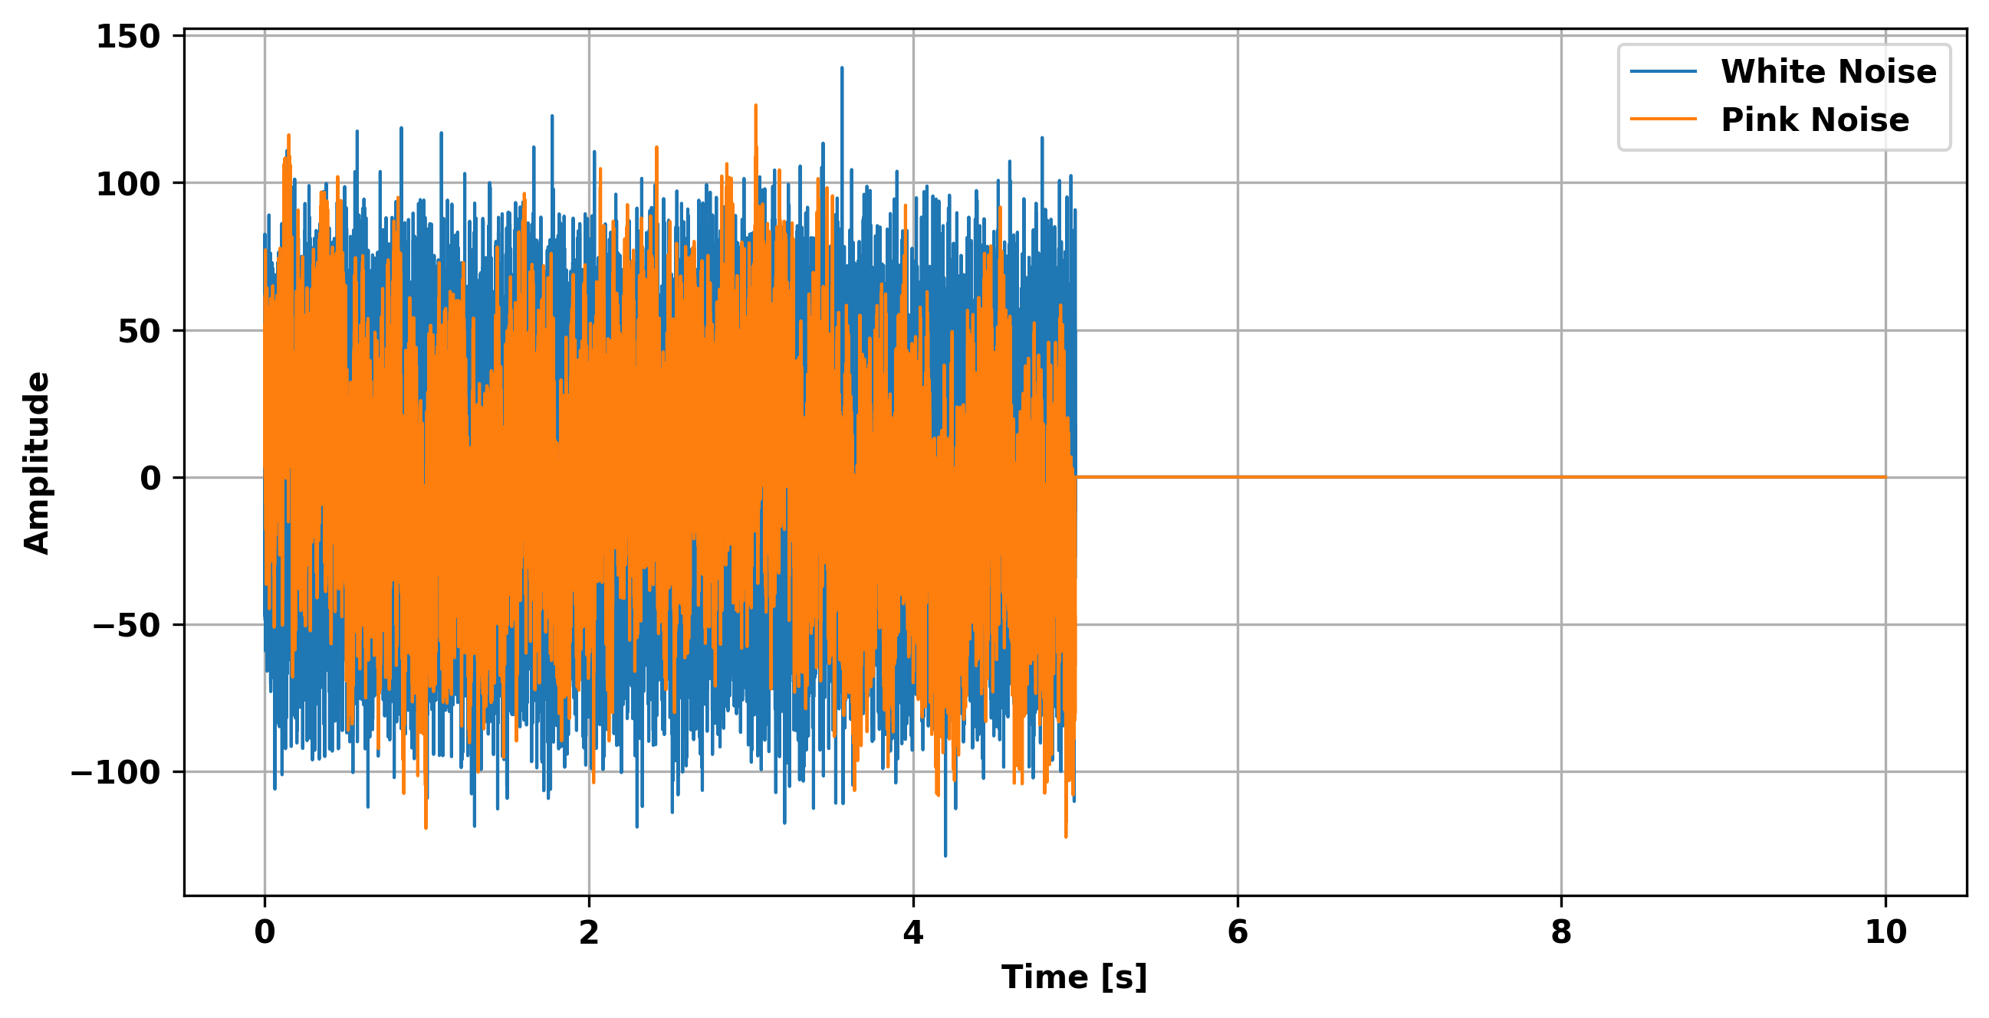

**Part C and Part E(ii)**

Part C asked to calculate the SPL of the A and C weighted white and pink noise signals (Table 1). Notably, the pink noise weighted SPLs are lower than that of white noise meaning that itis relatively quieter.

Table 1: Summary of SPL for White and Pink Noise

|  |  |  |
| --- | --- | --- |
|  | White Noise | Pink Noise |
| Original SPL | 1.063 | 1.063 |
| A-Weighted SPL | 1.474 | -4.615 |
| C-Weighted SPL | 0.615 | -2.178 |

Part E(ii) asked to plot the FFTs of the weighted and original signals and are depicted below (Figure 3 and 4). As expected because of the sqrt(1/f) magnitude, the original pink noise has much higher amplitude at low frequencies and lower at higher frequencies than the white noise. The weighted filters also seem to be working since they both attenuate lower frequencies, and the C-Weighted filter attenuates lower frequencies a less than the A-Weighted filter.

Figure 3: White Noise

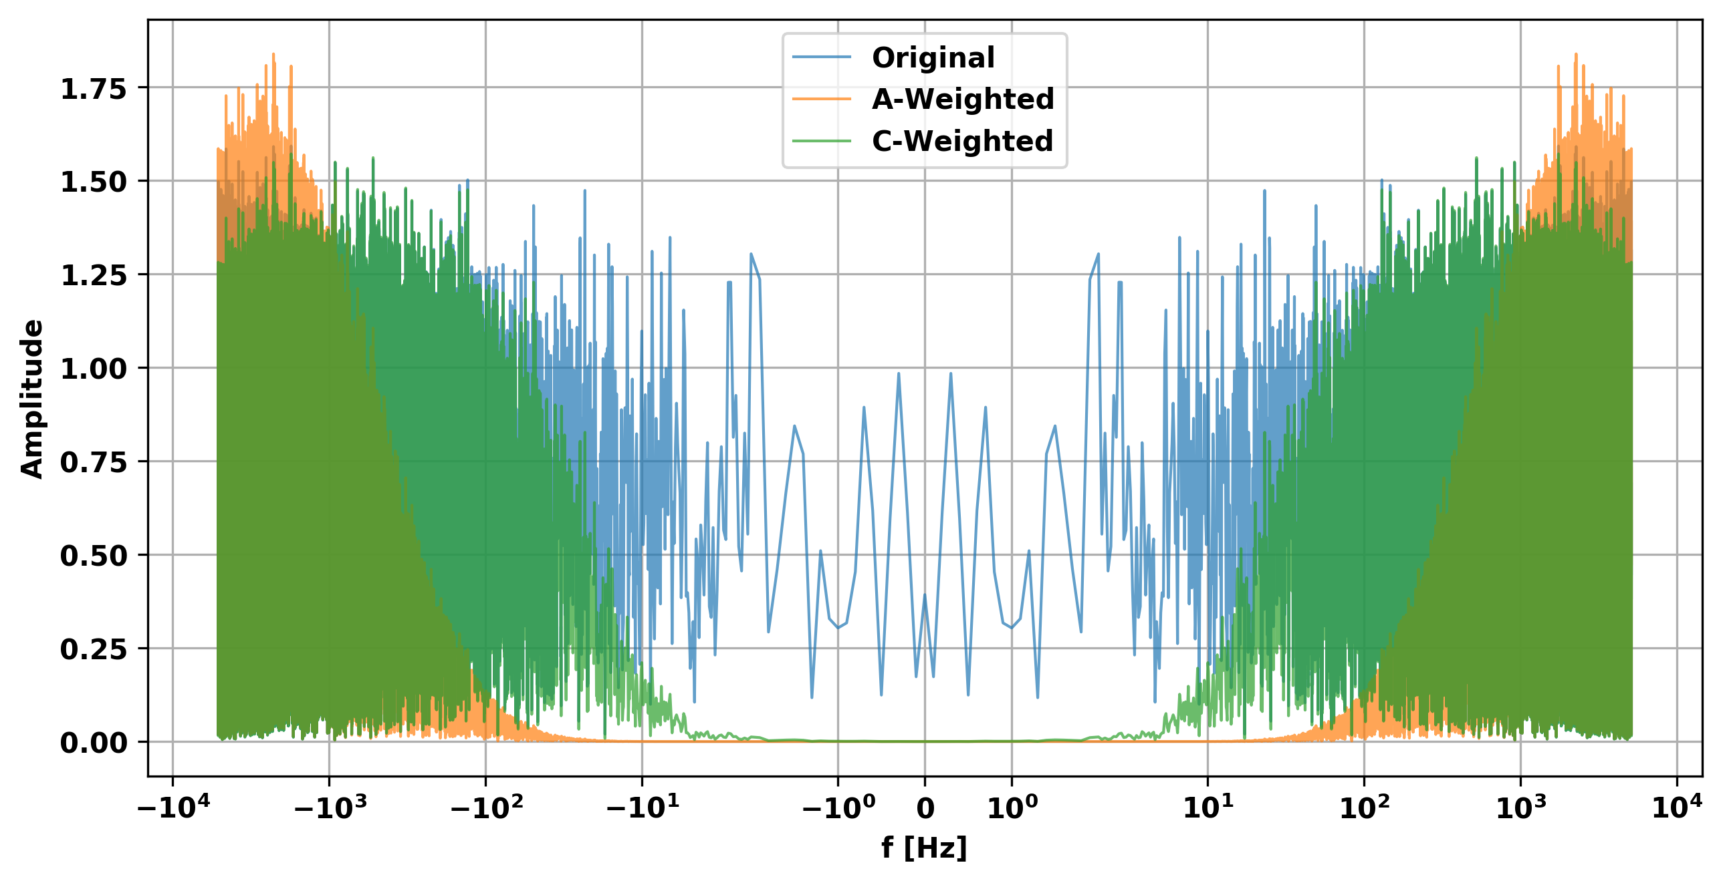

Figure 3: Pink Noise

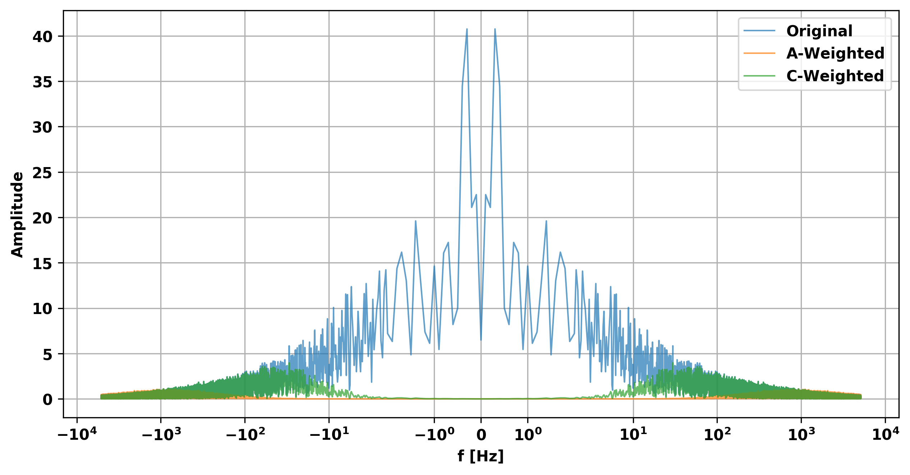

**Part D and E**

Part D and E of the assignment asked to create and apply butterworth filters to the frequency range from 125-4000 Hz for the white and pink noise. It can be seen that the pink noise has higher magnitude in the first three octave bands (associated with lower frequencies) and lower amplitude in the last two. It makes sense that the pink noise would have lower SPL in the higher octaves since the magnitudes are inversely related to the frequency (sqrt(1/f)) — this matches what is seen in Figure 3. However, I would have expected the white noise to show an increasing relationship since there are more frequencies in the higher bands — higher amplitudes seem to exist at higher frequencies shown in Figure 2.

Figure 2: Butterworth Filters (5 Octave Bands)

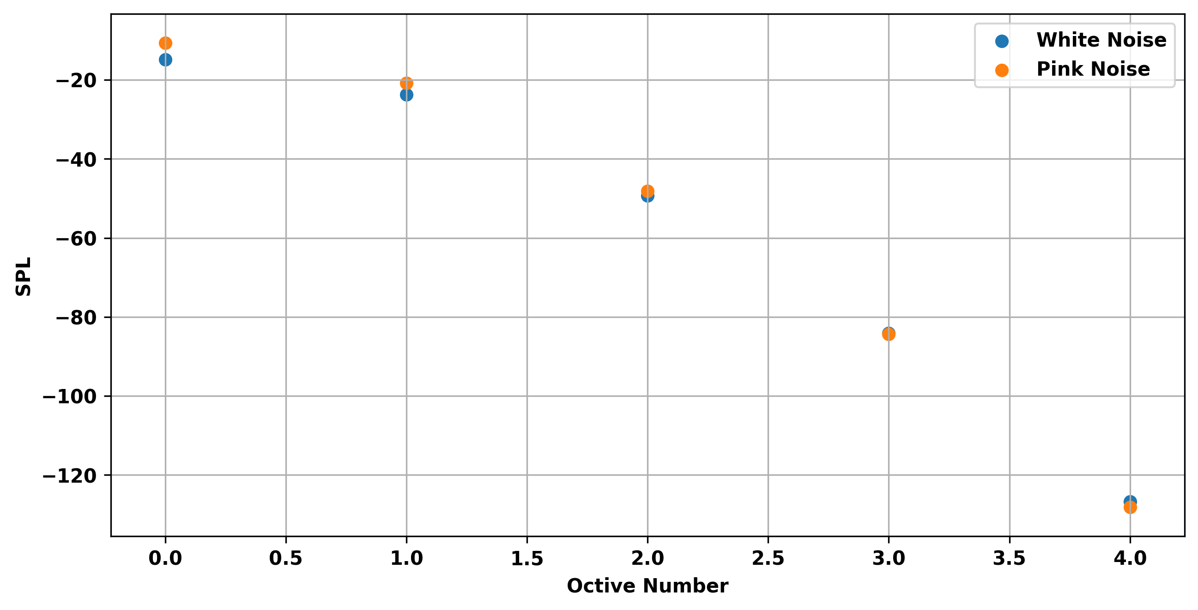

**Concluding Remarks**

The first take away is that A and C weighted filters attenuate low frequencies and Butterworth filters work like band pass filters. The second take away is that pink noise’s sound pressure is high at low frequencies, especially less than 1, and decreases toward higher frequencies; because of this fact, the SPL at higher octaves still decreases despite increasing frequency range. The outcome of this is that pink noise would sound relatively quieter than white noise, since most of the power is in low frequencies, which are harder for the human ear to hear.